Activity 3: Bokkshelf API + UI
The Bookshelf App displays books in a visually styled shelf layout. Users can view detailed information for each book, including the title, author, genre, and a short description. The app also allows users to add new books by specifying these same details. Additionally, users can filter or search for books by title or genre for easier navigation and organization.
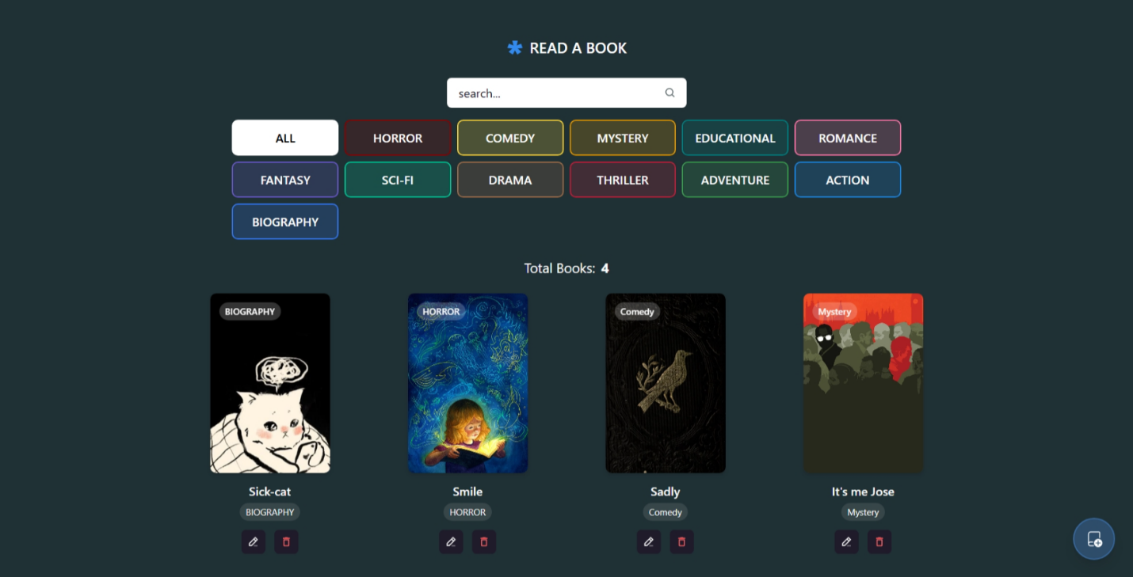

Bookshelf UI
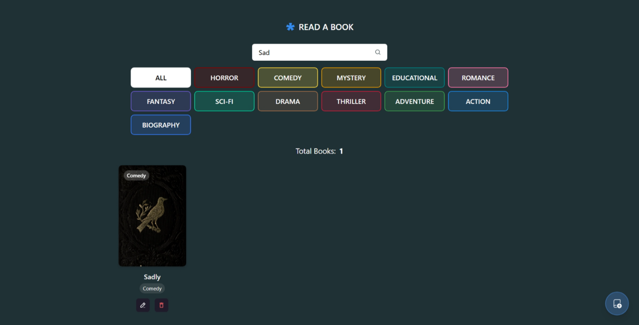

Searching for a book displa

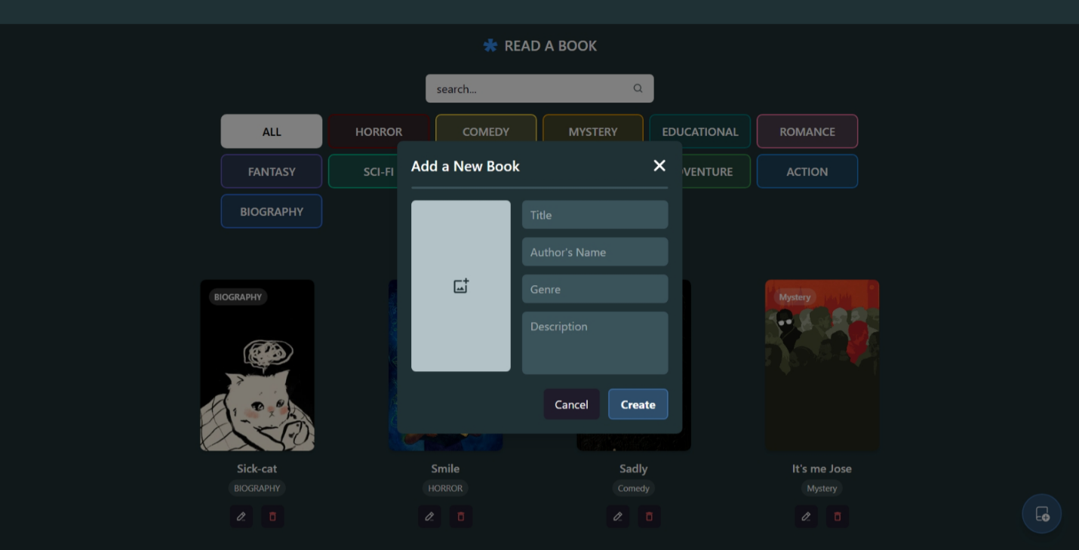

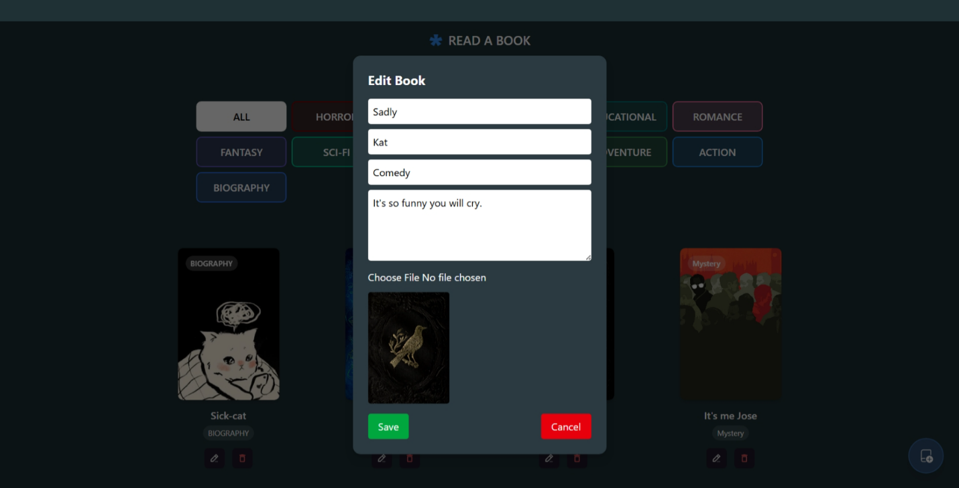

Adding a Book

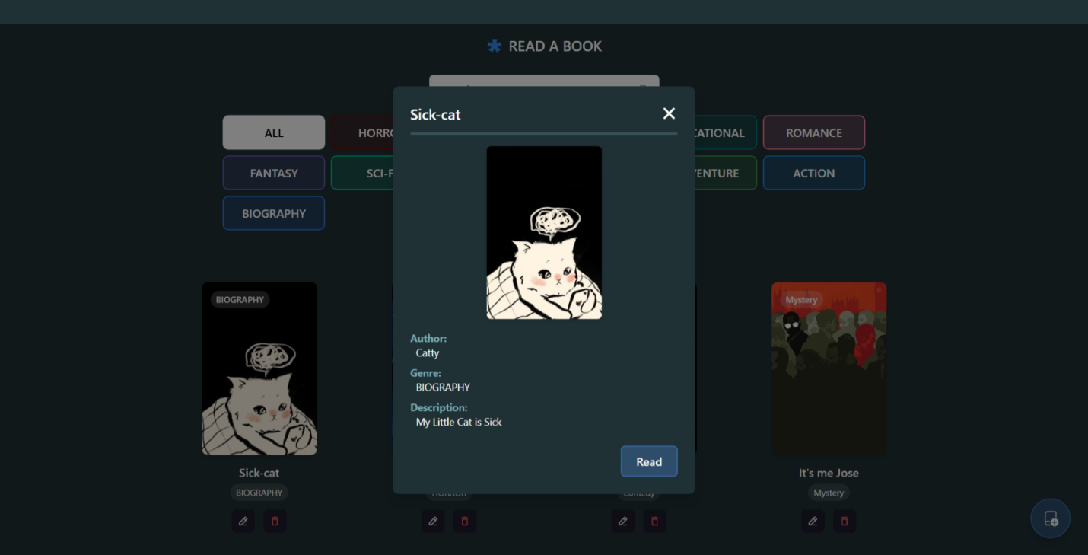

Displaying book details

Instruction: How to Run the project

- Clone the repository from this link: “https://github.com/skyana-08/ITEC116.git”
- Open your VS Code terminal and then type this: “cd Activity3/backend”
- Install dependencies inside the backend folder: “npm install”
- Start the backend by typing this and keep it running in the background: “npm run start:dev”
- Open a new terminal and then type this: “cd Activity3/frontend”
- Install dependencies inside the frontend folder: “npm install”
- To start the frontend type: “npm run dev”
- Open the provided link: http://localhost:5173
- Now you can use is as the bookshelf.

